**International Track Meet**

**Nga Puna Wai, Christchurch**

**22/02/2025**

**Technical Regulations**

1. Rules of Competition

The 2025 ITM Competition will be conducted using the current World Athletics Rules and Regulations

1. Safety

In the interest of Safety to athletes, officials, coaches, volunteers and spectators the following should always be adhered to:

* Spikes are only to be worn on the Field Of Play (FOP) or in the warmup area.
* Athletes are not to cross the FOP
* Warmups must be done in the designated warm up area and supervised by a coach
* Warmups in the FOP must be supervised by Officials and not commenced until instructed
* No glass is permitted in the FOP
* Athletes must take care when crossing the track and adhere to directions from officials.

1. Training

Training must be carried out in the Warm up area. The infield is not permitted for training.

The track will be open on Friday from 2pm to 5pm It is closed on Saturday morning as there is a Children’s meeting until noon.

1. Stadium Entry

* Entry to the FOP is via controlled gate access.
* No unauthorized person/s shall be allowed onto the FOP

1. Competition Bibs

* Athletes must collect their bibs from 4pm to 6pm at the Technical Information Centre (TIC) located under the control room on Friday February 21.
* Otherwise, they can be collected from the Marshmallow on the morning of February 22 from 10am.
* Athletes in picking up their bibs are **CONFIRMING** their entry into the events entered.
* Athletes will be provided with two bibs which must be worn on the front and back except for Jumps events which only need to wear one.
* Bibs need to be firmly attached and cannot be tampered with in any way.
* Any athlete that loses their bib needs to go to TIC for a replacement bib.

1. Personal Implements

* Athletes may submit two personal Implements for use during the competition.
* These must be lodged with the Technical Manager at the Technical room which is next to TIC at the following time : between 4pm to 6pm.

1. Draws

**FIELD**: the order for field events will be random.

After the first three rounds the top eight athletes with a valid trial will continue in reverse order for a further three rounds.

If 8 or fewer athletes then all athletes will have 6 trials.

**TRACK**: draws for the track events will be published after entry confirmations and will be published online.

1. Warm Up

* Warmups are not permitted in the FOP, except practice trials immediately prior to your event under supervision of Officials.
* Warmups are carried out at the warmup area adjacent to the Call Room.
* Throws warmups must be carried out at the appropriate throwing circle
* Hurdle warm ups can be undertaken on the grassed area adjacent to the call room and the back straight prior to the event. Athletes will report to the call room first (Call time 45 minutes), then be escorted to the back straight or top bend.Hurdle warmups will continue on the track after passing through the Call Room prior to their event.
* Wheelchair track athletes for events 200m and greater will be allowed one lap on the track to set their compensators immediately prior to the event.

1. Call Room Procedures

* The Call Room is located at the ‘Marshmallow’ by the Warmup area
* All athletes are required to report to the Call Room prior to the final published call time. Failure to do so will make the athlete liable for EXCLUSION from that event and from all other events they are entered in. Rule TR4.4 and WPA 5.4
* ONLY Water is allowed on the FOP
* Personal material that are prohibited on the FOP will be collected and maybe collected from Post Event after your event
* Throwing Frames and Racing Chairs for Para athletes will be checked in the Call Room
* Mobile Phones
* Field Event athletes, phones will be allowed onto the FOP but MUST be turned OFF and kept in the athlete’s bag. Any athlete found using or looking at their phone on the FOP will be issued a Yellow Card or a Red card.
* Track athletes must NOT bring their phones into the Call Room, please leave them with a responsible person.

**Call Room Reporting**

Athletes must report at the following times preceding the advertising start time or their event:

* Track Events – 20 minutes
* Hurdle Events – 45 minutes
* Field Events – 40 minutes

1. Shoes and Spikes

Competition shoes must be declared at entry and a random check will be made.

These must be approved World Athletics shoes.

Please ensure your shoes comply with WA shoe rules and are on the approved list via [Full list | LIST OF APPROVED ATHLETIC SHOES](https://certcheck.worldathletics.org/FullList) - if your shoes do not comply you will be disqualified from the event.

The Spike length requirement for Nga Puna Wai Track is

* Maximum length is 6mm (7mm will be accepted) except in High Jump where a maximum of 9mm is allowed
* Only Pyramid/Cone shapes are permitted.

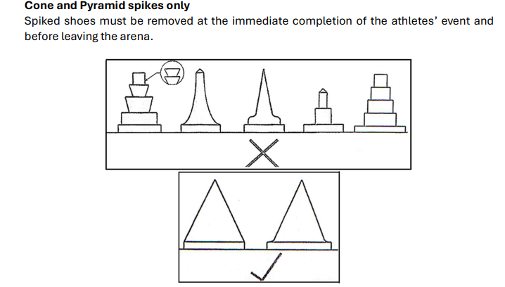

1. High Jump Progressions
2. Post Event Control

* All athletes **must** leave the FOP via Post Event Control
* Any goods confiscated at the Call Room can be collected at Post Event Control.

1. Starting Blocks

* Only starting blocks provided by the organizing committee shall be used.
* Private starting blocks are not permitted
* Athletes with a hearing impairment that wish to use a strobe light must advise TIC at least 2 hours prior to the competition.

1. Protests and Appeals

* Athletes must first Protests orally to the relevant Referee or within 30 minutes of the official time of the posting of the results.
* If the Referee can’t be located the athlete Must complete a verbal protest form at TIC within the time frame.
* If an athlete wishes to Appeal to the Jury they have 30 minutes from the time of the Referee’s decision to make an Appeal. This must be done in writing on the Appeal form and accompanied by a NZD$125 Appeal fee. This can be done at TIC.

1. Doping Control

* Anti-Doping will be present at the ITM and athletes may be required to undertake doping testing.
* Athletes may elect to have a representative/support person present
* Athletes will be collected at Post Event Control.

1. Media & Promotions

* Athletes should make themselves available for the event media conference held in Christchurch 2pm before the event.
* Athletes must exit the FOP via the Post event control then to the media zone, being available for media interviews and crowd interactions where reasonably practicable.
* Athletes are to be available when requested to visit the sponsor hosting area.
* By entering this event athletes grant the organizers an irrevocable right to use their name and images or video from the event for promotional purposes.

1. Prizemoney

* Prizemoney will be paid after the event to a bank account of the athlete or their nominated agent.
* Any athlete found to be in breach of anti-doping or integrity breaches will not be eligible for prizemoney, and any prizemoney awarded may be reclaimed by the organizers.